2/12/2017
5/25/2017
11/21/2019
6/15/2023
11/16/2023
Promontory School Wellness Policy
Rationale
The link between nutrition, physical activity and learning is well documented. Healthy eating and activity patterns are essential for students to achieve their full academic potential, full physical and mental growth, and lifelong health and well being. Healthy eating and physical activity are essential to reduce risk for many chronic diseases. Schools have a responsibility to help students learn, establish and maintain lifelong healthy eating and activity patterns. Well planned and effectively implemented school nutrition and fitness programs have been shown to enhance students’ overall health as well as their behavior and academic achievement in school. Staff wellness also is an integral part of a healthy school environment, since school staff can be daily role models for healthy behaviors.
Goal
All students in Promontory School shall possess the knowledge and skills necessary to make nutritious food choices and enjoyable physical activity choices for a lifetime. All staff in Promontory School are encouraged to model healthy eating and physical activity as a valuable part of daily life.
To meet this goal, the Promontory School adopts this school wellness policy with the following commitments to nutrition education, physical activity, nutrition guidelines, other school based activities and implementations. This policy is designed to effectively utilize school and community resources to equitably serve the needs and interest of all students and staff, taking into consideration differences in culture. Evidence based or best practice recommendations also influence the policy/goals. A committee of multiple positions within the community and school shall oversee compliance of the wellness policy. Committee membership is available to all.
Nutrition Education Goals
● The school cafeteria or eating area serves as a learning laboratory to support nutrition education with a goal of three nutritional learning activities per year.
● Utilizing the food service area as a learning laboratory to support classroom instruction through menu offerings and information
supporting healthy eating.
● The school will provide education for students to help them learn skills needed to practice lifelong healthy eating based on school meal nutrition standards and Smart Snacks standards. Information on these standards can be found at https://www.schools.utah.gov/curr/health?mid=908&tid=1, https://www.fns.usda.gov/tn/guide-smart-snacks-school and https://www.schools.utah.gov/cnp/NSLP?mid=1201&tid=0.

What are the Smart Snacks Standards for foods?
To qualify as a Smart Snack, a snack or entrée must first meet the general
nutrition standards:
• Be a grain product that contains 50 percent or more whole grains by weight
(have a whole grain as the first ingredient); or
• Have as the first ingredient a fruit, a vegetable, a dairy food, or a protein food; or
• Be a combination food that contains at least ¼ cup of fruit and/or vegetable
(for example, ¼ cup of raisins with enriched pretzels); and
• The food must meet the nutrient standards for calories, sodium, fats,
and total sugars."
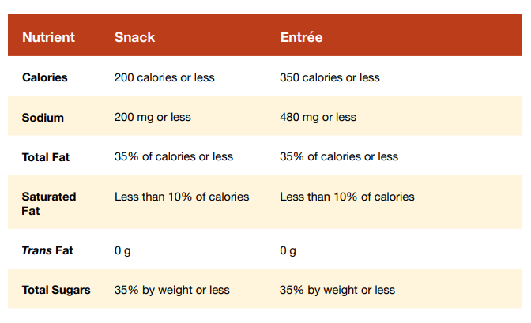
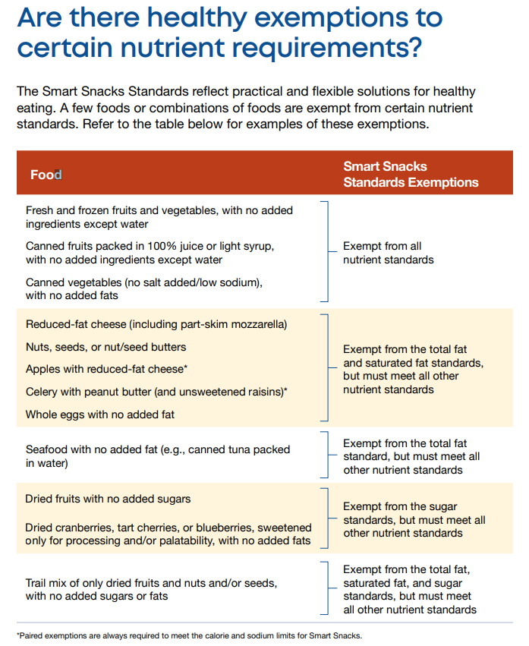

Promotion of Healthy Eating and Nutrition Guidelines
● Encourage the increased consumption of a variety of healthy foods, including fruits, vegetables, whole grain and low fat dairy products.
● Offer food and beverages outside the lunch and breakfast meal service which are a good source of nutrients, moderate in sodium, moderate or low in fat, and moderate in sugar that is not naturally occurring in the food, moderate in calories and are in compliance with smart snacks guidelines and regulations.
● Strive to improve student nutrition behaviors on the school campus; include an increase of healthier meal choices by students to include fruits, vegetables, whole grains, and low fat dairy products.
● Serve school meals which meet the USDA nutrition standards (https://www.fns.usda.gov/school-meals) for all meals. Provide sufficient choices, including new foods and food prepared in new ways to meet the taste preference of the students.
● Designated lunch periods for all students offer sufficient time to enjoy eating healthy foods. Lunch periods will be scheduled near the middle of the school day when possible.
● Students shall be encouraged to test healthy food items with which they are not familiar to promote behavior change and healthy school meal consumption,
Promotion of Healthy Eating and Nutrition Guidelines
● Food and beverages are not used as reward or punishment as they may undermine healthy eating practices, interfere with kids' natural ability to regulate their eating and also encourage them to eat when they're not hungry to reward themselves or alternatively withhold food to punish themselves. Refer to the Wellness Policy Procedures and Guidelines for a list of alternative ways to reward children.
●.Classroom celebrations that involve food will be allowed at the Administration’s discretion. Such celebrations shall comply with the following:
a. All foods made available will comply with state and local food safety and sanitation regulations.
b. Healthy snack choices and/or options will be offered to students, faculty and staff as part of the celebration. See smart snack table above for suggestions as well as guidance from the Director for any additional clarification.
c. Faculty, staff, and parents will make healthy and fun activities the focus being of the celebration rather than food.

- In some classrooms a snack time may be implemented at the Administration's discretion in order to combat fatigue, particularly for those who have an earlier lunch period.

- Distribution of food-based birthday treats in the classroom will not be allowed and parents will be encouraged to bring non-food items as birthday treats.

● Advertisement of foods not in compliance with smart snacks regulations is not allowed. Meaning, foods sold in competition with the school lunch program. (Ex. fundraisers) during school hours shall not be advertised.
● Provide student’s opportunities to practice healthy habits – they can choose from an array of healthy food options, eat in relaxed and comfortable surroundings and enjoy daily physical activity.
Physical Activity
● Schools should ensure that every student from kindergarten through twelfth grade receives regular, age appropriate, quality physical education and follow the state core curriculum guidelines found at
http://www.uen.org/core/pe/.

● Provide within the school environment a safe enjoyable activity for all students including those who are not athletically gifted.
● Provide, through physical education, safe and satisfying physical activity for all students, including those with special needs.
● Provide for fitness education to help students understand and improve or maintain their physical well-being.
● Promote the benefits of doing regular amounts of physical activity now and through life.
● Schools should ensure that physical activity facilities on school grounds are kept safe and well-maintained.
Goals for Physical Education
● Our students can demonstrate willingness to try new activities and skills with a positive attitude.
● Our students can demonstrate good sportsmanship toward themselves and crew members.

Goals for Other School Based Activities
● The after school environment promotes healthy eating and physical activity where appropriate.
● Dining room supervisory staff (teachers, aids, etc.) shall receive appropriate training in how to maintain a safe, orderly, and pleasant eating environment.
Staff as Role Models
● Train the staff who supervise student dining areas to encourage healthy eating patterns through a positive daily experience. Annual training is required of all nutritional staff in accordance with state professional standards.

Food Safety/Food Security
● All foods made available will comply with state and local food safety and sanitation regulations.
● Implement Hazard Analysis and Critical Control Point (HACCP) plans and guidelines to prevent food illness in school.
● All food service equipment and facilities must meet applicable local and state standards concerning health, safe food preparation, handling and storage, drinking water, sanitation and workplace safety.
● All food and nutrition labels and or manufacture information are available upon request and will be obtained to the best of ability.
Measuring Implementation:
● The Nutrition Director with the help of supporters will conduct a review of the progress toward school wellness policy goals each year and identify areas for improvement. The progress report shall be available to the public posted on the schools website.
● Prepare and submit a yearly report to the school’s administrators regarding the progress toward implementation of the school wellness policy and recommendations for any revisions to the policy as necessary. This report shall be available to the public upon request.
● Assess how well the policy is being managed and enforced periodically, not going more than 3 years without assessment.

